Approve or Deny WBL Records
This Report in AET helps to quickly view and evaluate if the student’s WBL records include required details. Teachers/WBL Coordinators can view, provide comments, approve or deny the record and offer students ways to improve their work. Easy three steps!

Step 1: Choose “Reports” menu and view “Student Detail Report”

Step 2: Choose “List of Time Entries” to view WBL details
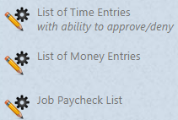
Use this report to verify time entries only.

- Use filter tools to sort your list by classes, grades, WBL supervisor or more
- Choose the dates range of records to also narrow your list! 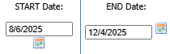
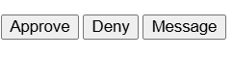
Step 3: On each entry, view the details and choose your action!

Message = develop an AET message but still need to choose Approve or Deny.
Deny = develop an added message to the student, if needed, the entry is removed from the list, and the student gets an AET message to improve.
Approve = done and removes it from the list.

